**An introduction to Kent Sport’s draft**

**Children and Young People Strategy 2021-2026**

**Kent Sport is the Active Partnership for Kent and Medway**

children playing football

**"Helping children and young people**

**to be**

**physically active**

**every day”**

# Introduction

Kent Sport is an integrated team funded by Sport England and Kent County Council, working together as the Active Partnership for Kent and Medway, and is one of 43 Active Partnerships nationally. We work with partners and networks across the county, including local authorities, schools, clubs, health professionals, and voluntary organisations, to provide opportunities for everyone to get involved in sport and physical activity for their enjoyment as well as their health and well-being.

The purpose of this document is to share our draft children and young people strategy “Helping children and young people to be active every day” and ask for your feedback. We as a team have limited resources, but we are very keen to ensure those resources are spent in the most effective way.

We aim to produce our final strategy by the end of 2020 which will feed into our wider team strategy due to be published in Spring 2021.

This document provides **context**, including reasons why this is such an important issue, as well as examples of why children and young people (CYP) are not active. It also describes **how** we intend to work, to address the issue, followed by **what** we plan to do i.e. what our priorities are and the actions we will take. This will allow you to provide feedback in terms of whether or not we are on the right track, or whether we’ve missed anything.

**Vision**

**Our vision is that every child and young person develops the skills, motivation and understanding to enjoy being active. And has the opportunity to be active every day as part of a healthy, happy and fulfilling life.**

# Why is it important for Children and Young People to be active?

**Active Children and Young People have better physical and mental health**

* The Active Lives survey shows there is a positive association between active CYP and higher levels of mental wellbeing and individual development.
* More physically literate CYP are more likely to be active.
* [Chief Medical Officer guidance](https://assets.publishing.service.gov.uk/government/uploads/system/uploads/attachment_data/file/832861/2-physical-activity-for-children-and-young-people-5-to-18-years.pdf) states: Physical activity maintains healthy weight and improves general health and fitness.

**53.5% of Children and Young People are not active enough**

* 340,000 CYP aged 5 to 19yrs live in Kent and Medway. Over half (53.5%) do not meet the Chief Medical Officer recommendation of 60mins/day.
* 31% are doing less than 30mins/day.
* Habits were forced to change during covid-19. Most children were less active, but some benefited from being active in different ways - with their families or via online sessions.

**Not all Children and Young People have the same opportunities to be active**

* CYP from the least affluent families are less likely to be active and less likely to enjoy being active.
* Girls are less likely to be active than boys.
* Asian and Black CYP are most likely to do the least amount of activity each day.
* CYP are likely to be more active outside school than in school.

**Some Children and Young People have even more to gain from being active**

* When activity is delivered in the appropriate way, it can increase the health and well-being of vulnerable CYP.
* This includes those who live with poor mental health; are at risk of offending; experience abuse, trauma, bullying, loneliness or bereavement.

# What have we learnt so far?

We have learnt there are many variables which contribute to any child's ability to be active and this changes throughout their life. However, we have also learnt that those within certain groups find it more difficult to be active than others i.e. from less affluent families, Black, Asian and Minority Ethnic communities and those living with a disability or long-term health condition (LTHC).

* **Life events:** A child experiences several life events when growing up such as starting school, moving up to secondary school, getting their first phone, exams, relationships and starting work.
  + These factors can all disrupt a child’s life and may result in them having to stop being active, e.g. they can’t take part in after-school clubs as their new school is a bus journey away, or they have to study for exams.

* **The influential people in their lives**: Parents/carers, teachers, youth workers, social media and celebrities can all influence how active a child is.
  + A parent or carer makes decisions for a five-year-old, whilst a 14-year-old may play a sport to be with their friends.
* **Access to activities:** A child will chooseto take part inan activity they enjoy,however access to this will vary depending on what is available to them.
  + How close is the local park or leisure centre? Does the local club have suitable equipment and a coach with the knowledge to adapt and include a child with a disability?
* **Barriers to activity**: All children should have access to PE and sport in school, however outside school there are a range of barriers which are often more prevalent for children in the identified groups.
  + These include a lack of money, time pressures, competing interests, negative experiences at school, low levels of self-confidence and competence, fear, lack of role models in communities where being active is not the norm.

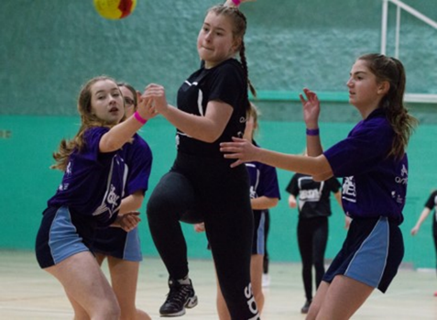 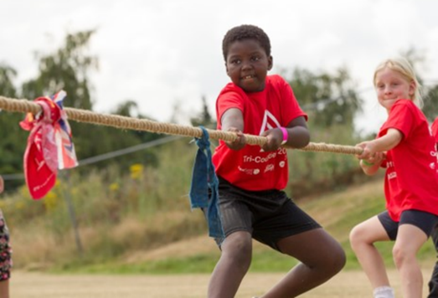

# How we plan to tackle inactivity and reduce the inequalities CYP face in sport and physical activity

**HOW**

**Collaborate with organisations who work with CYP who are less likely to be active**

**Help to keep CYP safe and promote their wellbeing in and through sport and physical activity**

**Help develop a workforce who are skilled at engaging with CYP and facilitating behaviour change**

**Monitor, evaluate & share our learning to ensure successful projects can be replicated across Kent & Medway**

**Consult with CYP to ensure we support the right activities delivered by the right people**

We have learnt that it is important to understand how we work in order to bring about change and help increase the number of active children in Kent and Medway. Therefore, we plan to adopt the following principles when working on projects for children:

* **Identify and collaborate** with the right organisations i.e. those who work with children who are less likely to be active (BAME, less affluent, LTHC, disability), a number of these organisations may not have a remit to provide physical activity for these children.
* **Consult with** i.e. talk to children and young people about what activities they like to do and why they don’t take part – it is now widely known that the more traditional sports are only enjoyed by some children (and adults). If you intend to provide activities, they need to be attractive to them.
* Not all coaches/leaders and even teachers understand how to encourage a reluctant child to take part in an activity. The **workforce** needs to be skilled at engaging with children, which is more important, in many cases than having technical knowledge.
* **Keeping children safe** is an absolute priority and therefore must be embedded in all planning.
* We need to keep **monitoring and evaluating** projects i.e. listen, learn and share what works well, as well as what doesn’t work, so organisations can replicate great practice.

What we plan to do to tackle inactivity and reduce the inequalities CYP face in sport and physical activity

**1. Provide advice and information to organisations who deliver or commission sport and physical activity for CYP:** e.g. Schools, youth services, health services, sport and physical activity providers, housing associations and community organisations.

* Share insight and case studies to enable replication of successful projects.
* Communicate through e-news, social media, conferences, workshops, and create networking opportunities.
* Provide advice to Primary Schools on their use of the PE & Sport Premium funding to ensure they encourage all their students to be active, and to meet the funding criteria.
* Create links to community sport and physical activity providers.

**2. Provide funding and support for projects and organisations who focus on CYP who are less active, in particular those CYP from the following groups:**

* Lower Socio Economic (linked to our team ‘place-based’ work)
* Black, Asian and Minority Ethnic
* Those living with a disability or a long-term health condition

**Examples of funded projects include;**

* Youth projects – primarily aged 11 to 16 years
* Year 6 transition programme
* Small grants to support clubs and providers deliver a positive experience to CYP
* Develop the workforce, both adults and CYP
* Longer term funding to help develop a sustainable option

**3. Support the workforce to develop the right skills to engage with inactive CYP:**

* Professional development for coaches working with inactive CYP in schools, clubs and the community.
* Support training for the wider school workforce including teachers, SENCo, governors, senior staff, family liaison to ensure a positive experience.
* Young coaches, volunteers, and leaders.
* Wider children's workforce e.g. youth workers.

**4. Continue to deliver the School Games County finals and festivals:**

* Work with School Games Organisers to ensure a smooth transition into county events.
* Provide events for different levels of ability to enable CYP of all abilities to take part in county-wide events.
* Deliver events for targeted groups e.g. disability, girls, mental health.

**5. Marketing and communications:**

* Raising awareness of the benefits of being active.
* Providing information on how and where to be active.
* Promote national and develop local campaigns.

**6. Insight:**

* Coordinate the Active Lives CYP Survey and share the national findings with partners.
* Share national and local insight to help the workforce and providers understand the barriers and motivations of less active CYP.

That concludes our draft strategy and we very much welcome your feedback and suggestions to help us prioritise our resources to achieve the greatest impact and encourage more children and young people to be active every day.

# Questions for feedback:

1. Is the strategy on the right track? Score 1 to 10.

(1 = totally missed the mark, 10 = I am completely supportive of the proposed direction).

1. Which elements of this document/presentation do you like the most?
2. Which elements of this document/presentation do you like the least?
3. Any further comments e.g. is anything missing?
4. What is your role/interest in helping CYP to be active?

## Please respond to these questions in any of the following ways by 30 November 2020

* Online form at: <https://surveymechanics.com/s/FD98>
* Email: [kentsport@kent.gov.uk](mailto:kentsport@kent.gov.uk)

**PLEASE PROVIDE YOUR FEEDBACK BY 30 NOVEMBER 2020**